World Wildlife Day: Be the change wild animals need

03/03/2018

Every time you choose responsible tourism, you’re ensuring a better future for wild animals. World Wildlife Day reminds us of the need to protect these intelligent species that make our forests and reserves worth visiting and enjoying.

This is not the future most tourists want for our friends in the wild.

None of us would imagine a world without them – yet people have continuously been the greatest contributors to wildlife cruelty.

The sad reality for wild animals

In Asia, baby elephants are taken away from their mothers. They’re forced through a horrific training process which breaks their spirits and makes them submissive enough to be ridden by tourists. Currently, 3000 elephants are in captivity, living in the most deplorable conditions, as revealed in our [‘Taken for a ride report’](https://www.worldanimalprotection.ca/sites/default/files/media/takenforaride.pdf).

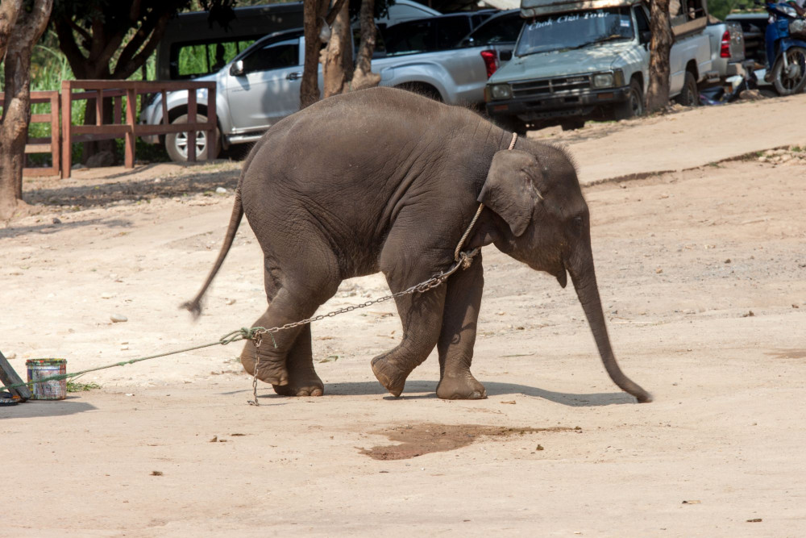

An Elephant at a venue in Thailand where elephants are kept in captivity and used to entertain tourists. Photo: World Animal Protection / Saranya Chalermchai

Big cats are among the most widely admired animals across the globe. However, today these charismatic predators are facing many and varied threats, which are mostly caused by human activities. In South Africa, lions are taken away from the wild, tamed to conform to human orders and forced to walk with tourists.

Our report ['Breeding cruelty'](https://www.worldanimalprotection.ca/sites/default/files/media/ca_-_en_files/wildlife-not-entertainers-lion-report-final.pdf) exposes the unacceptable suffering of lions caused by cruel tourist activities.

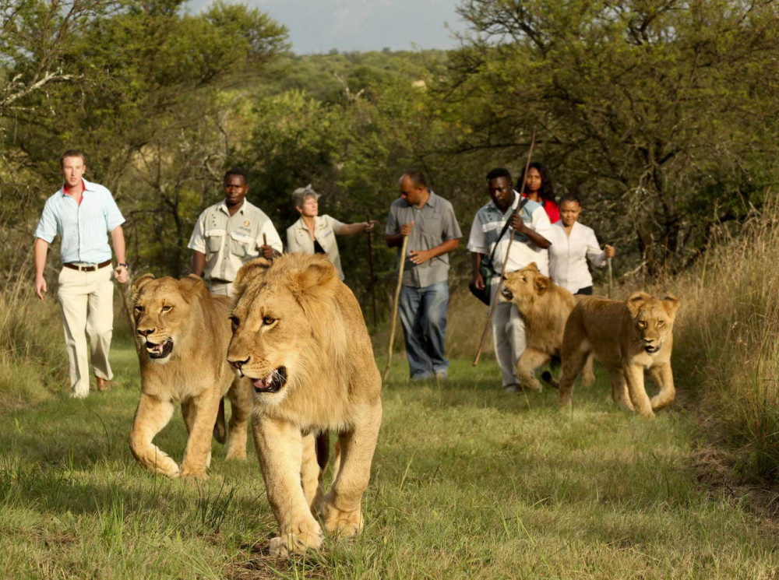

Tourists 'walk with lions' at a resort in South Africa. Photo: CC BY-SA 3.0 (via Wikimedia)

Become a conscious tourist

This is not the future most tourists want for our friends in the wild.

Awareness is your first step towards creating a cruelty-free future for wildlife. Tourist venues are keen to hide the cruelty subjected to the animals they keep. It can be hard to see the pain these animals are going through, regardless of how closely you look.

Our [animal-friendly tips](https://www.worldanimalprotection.ca/wildlife-not-entertainers/what-you-can-do) will help you prepare better for your next holiday. You’ll be able to know what welfare issues to look out for when visiting the next tourist site.

Together we can do more

Last year, together with 250,000 people, we moved Instagram to include an advisory page for anyone searching for #tigerselfie and other hashtags which could be associated with wildlife cruelty.  Now, when any of Instagram’s 800 million users searches for harmful interactions with animals, they will be warned about the dangers of this trend.

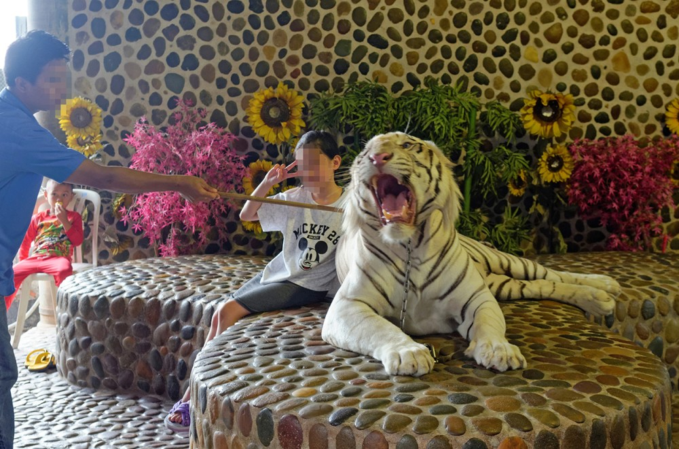

Tourists pose for photos with captive tigers at Million Year Stone Park, Thailand. Photo: World Animal Protection

If you haven’t signed up to this ask, you still have time. Commit to cruelty free selfies by [adding your name](https://www.worldanimalprotection.ca/wildlife-selfie-code).